(Your signature here)

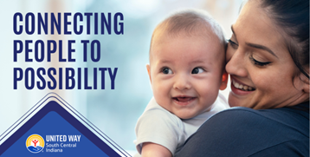

Nearly half of families in our region are just one emergency away from poverty.

Together, we’re tackling challenges no one can solve alone

**Get involved to help connect people to possibility.** [**Give today!**](http://www.monroeunitedway.org/givenow)